Using Google
Type in the search bar PREZI
Click the blue box “get started”
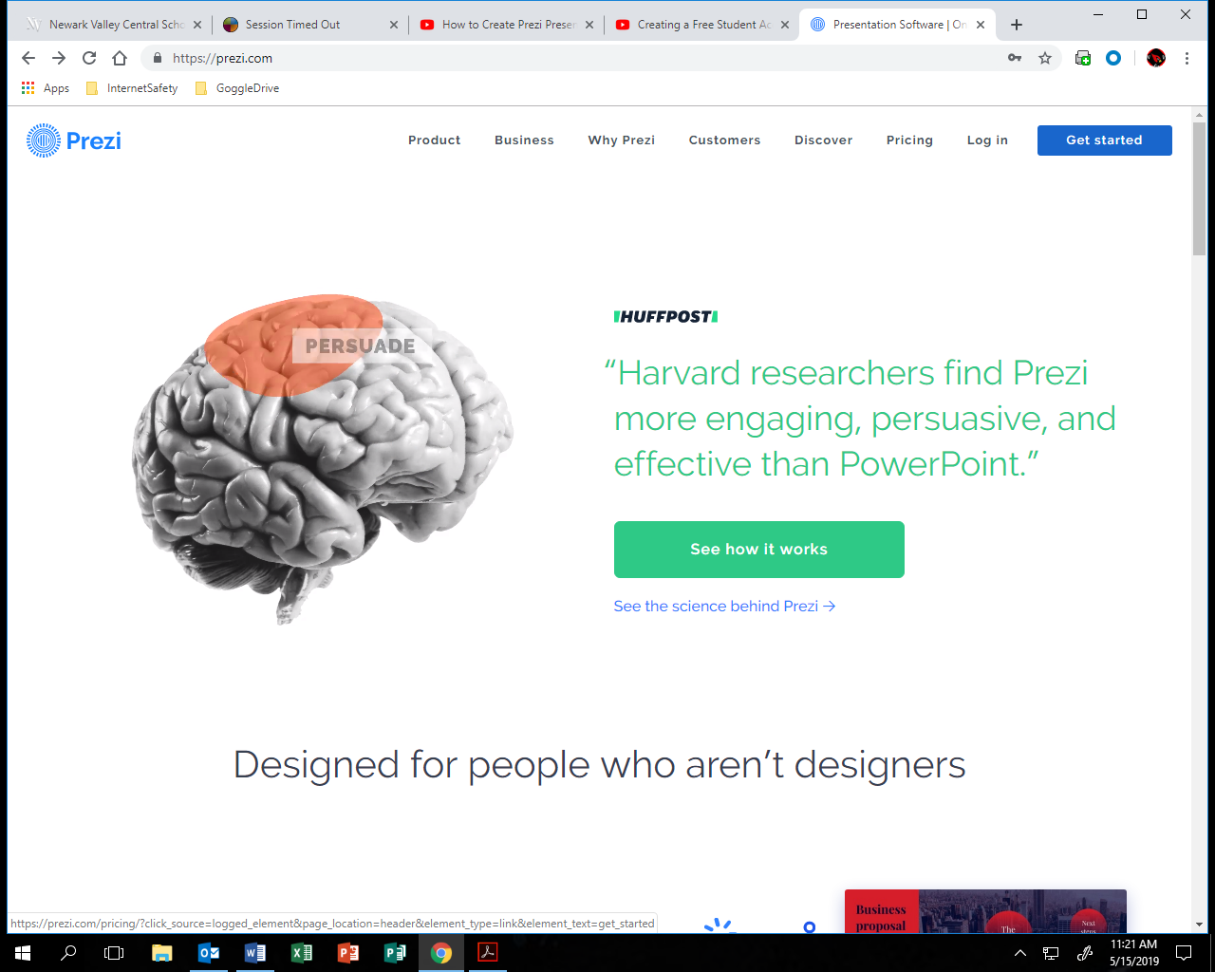

Next select basic

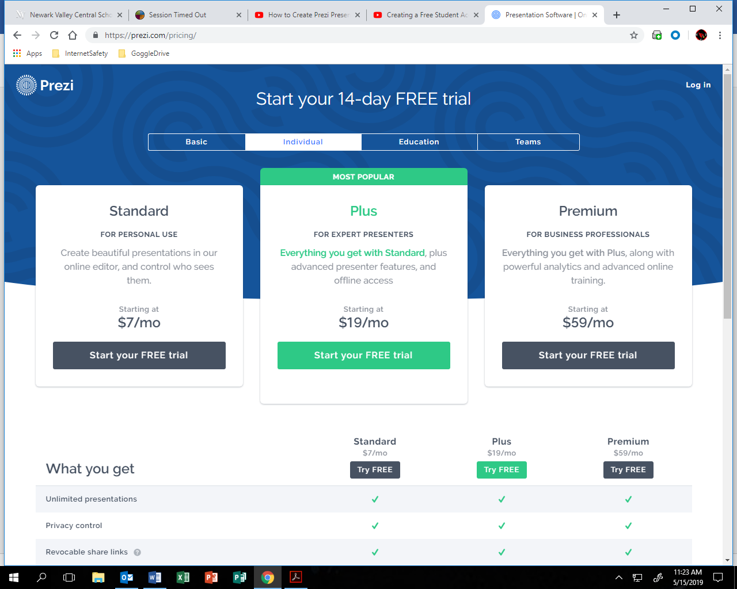

Select basic “Start today for FREE” CLICK Continue

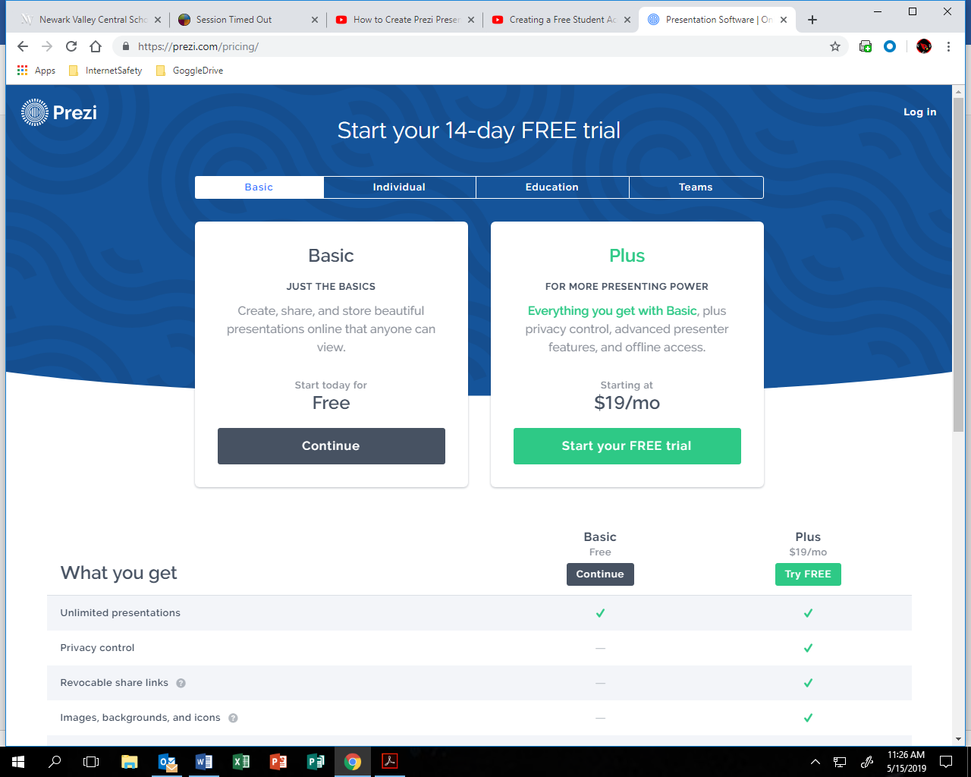

When creating you free Basic account use your school email (first.last@nvcs.stier.org)

